**Name : Nishit Jain**

**Roll No : 19102B017**

**Branch/Div : CMPN/B**

**Subject : Audit Course Level 1 Task.**

**Project Name : The Sagem Store**

|  |  |
| --- | --- |
| Front End Tools | HTML 5, CSS3 |
| Project Leader | Nishit Jain |
| Project Language | English |
| Country | India |
| Reference sites | www.w3schools.com |
| Github Repository Link | <https://github.com/nishit69/audit_task_1> |

**Project Description :** The V-eats is small initiative for taking small canteens online. The whole intension of this project is being able to create a responsive website which has features of carting, home page , search and basic E-commerce website features. This is a part of an Audit Course named “Industry Ready Web Developer” in which I have used Basic HTML and CSS to create a raw layout of the website and futher improvisations are needed to make it more dynamic and ready to use which will be done as we approach futher levels. Below attached are the screenshots of the work done till now.

**Screenshots:**

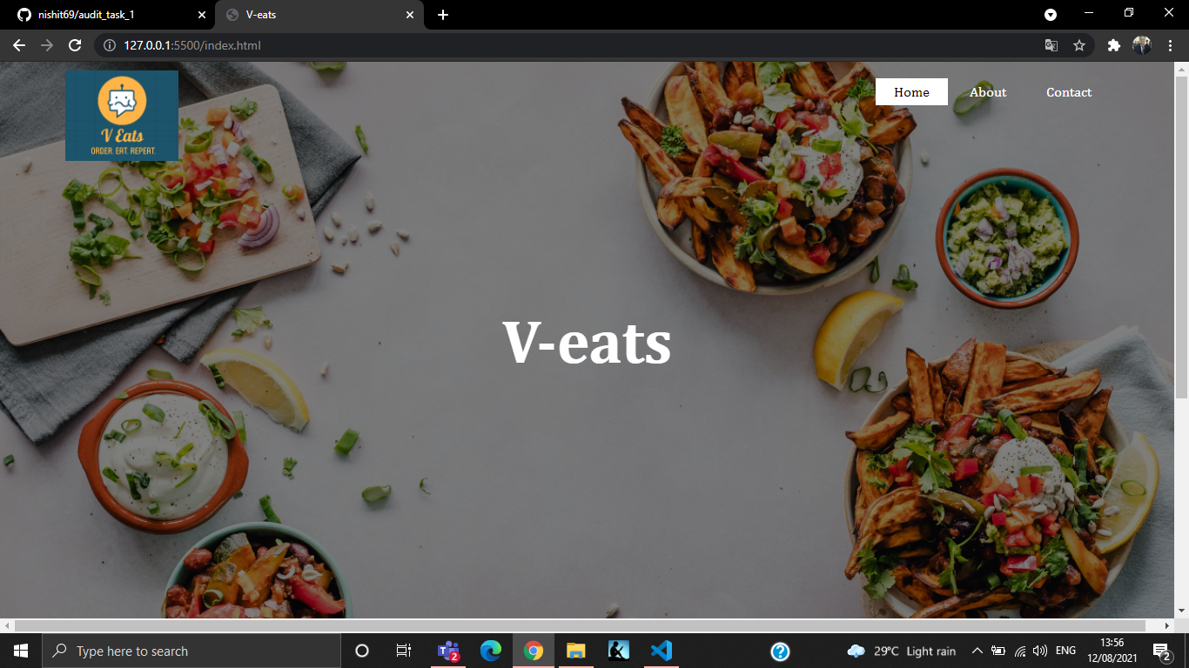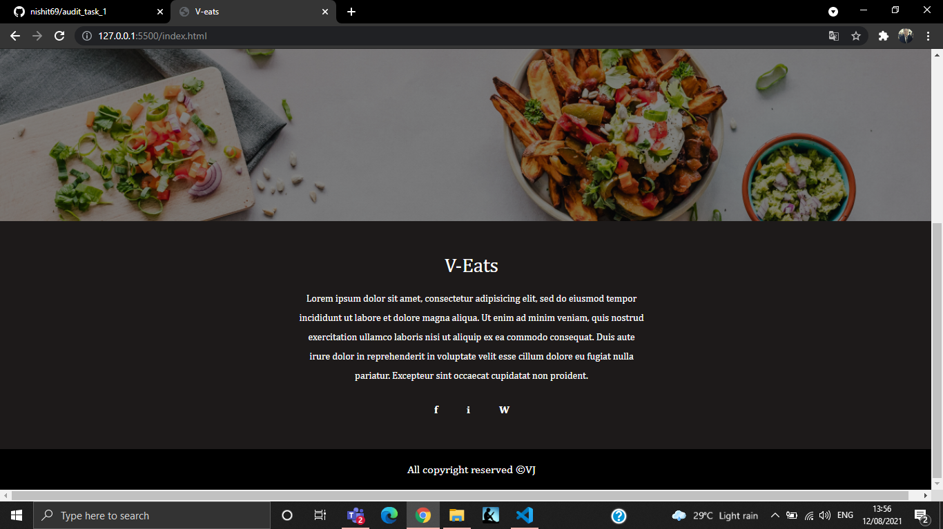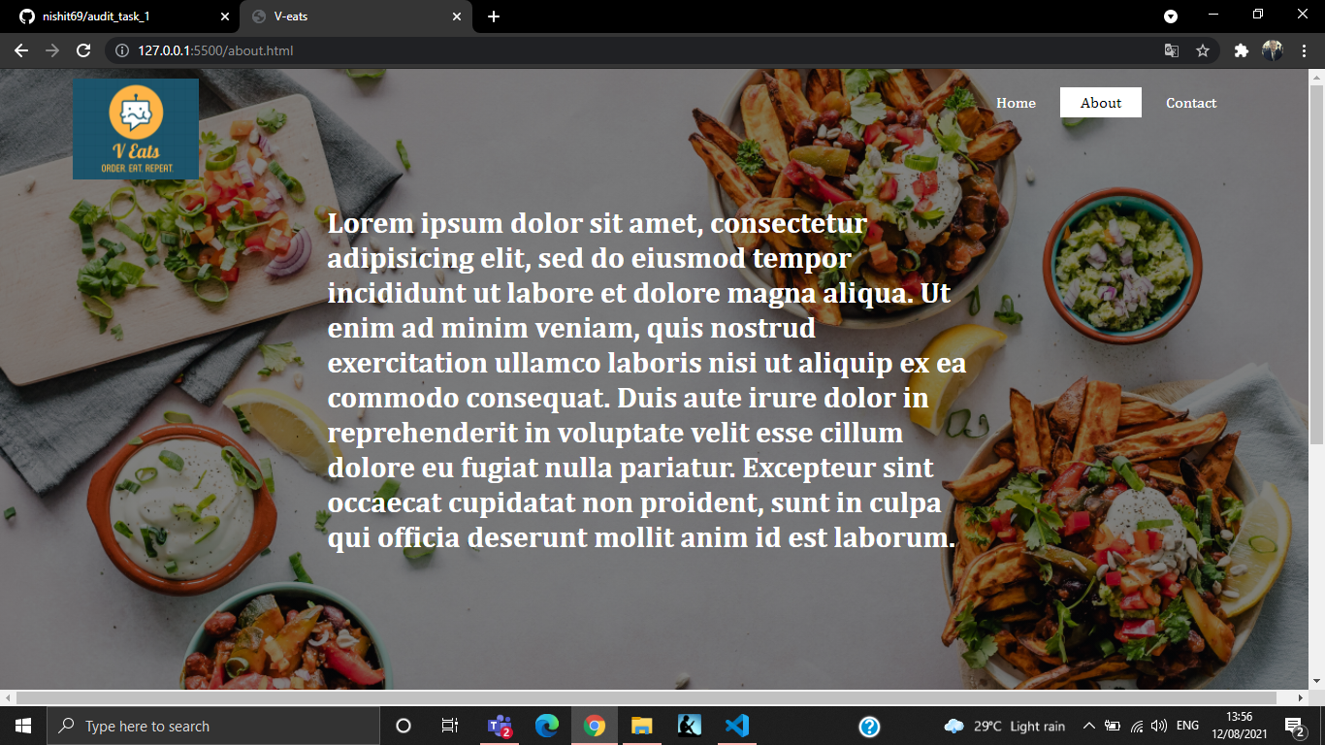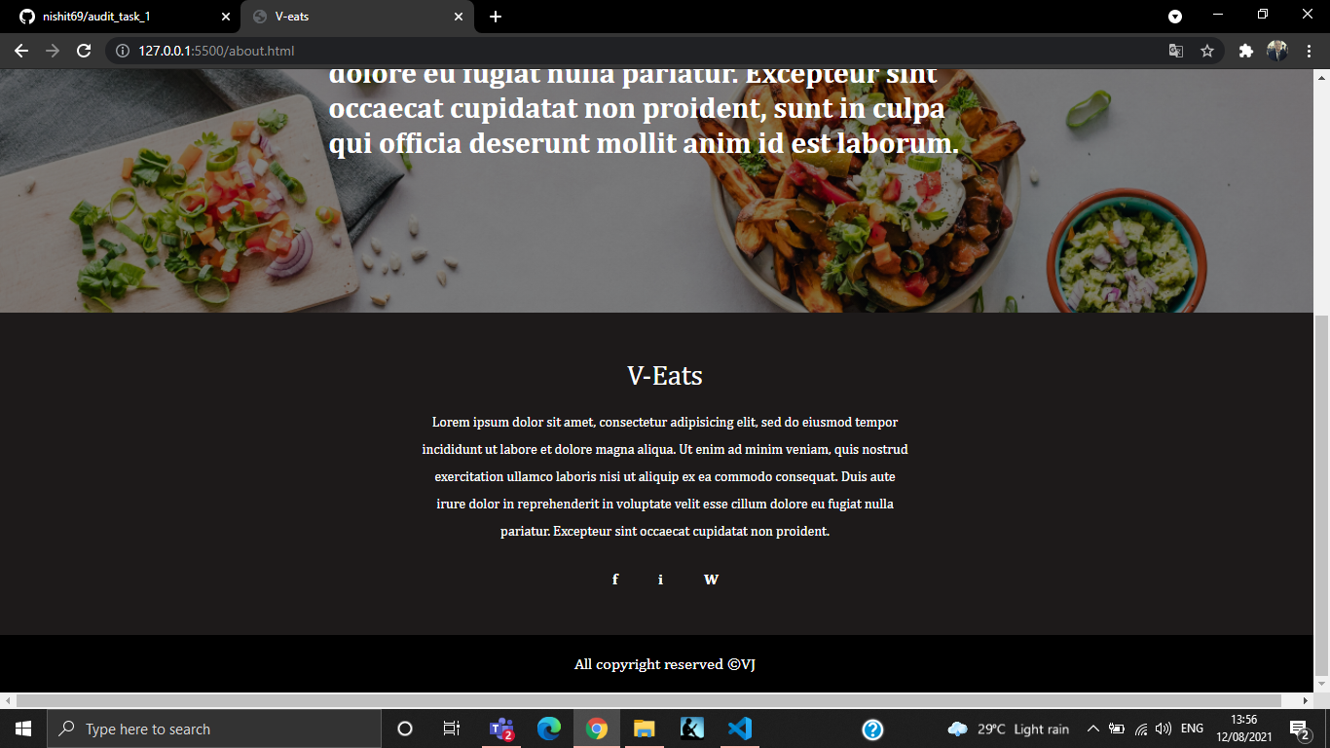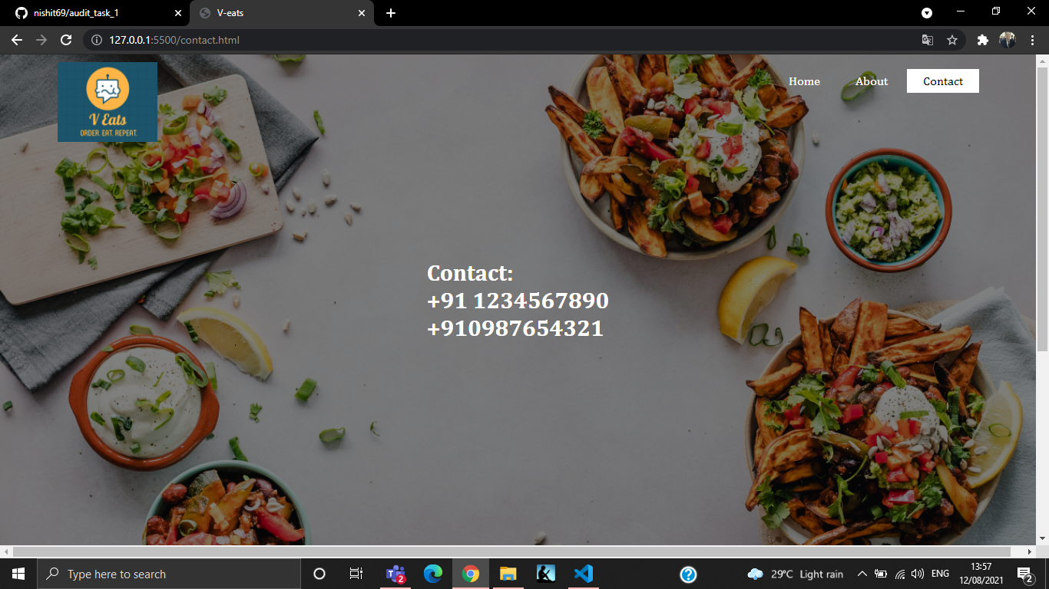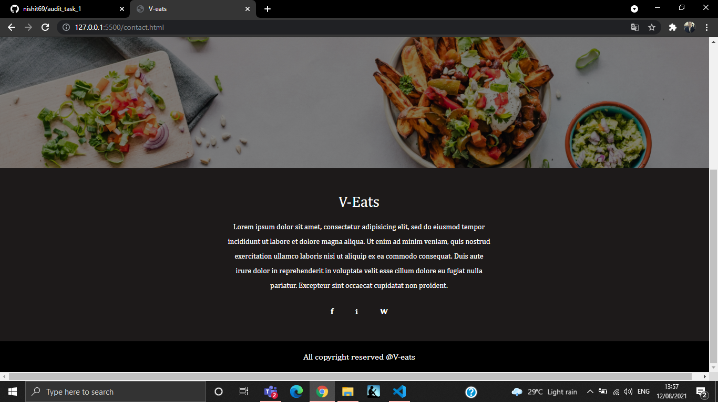

**Repository Link Here : https://github.com/nishit69/audit_task_1**